Name: AYUSH KUMAR DUBEY

Roll No.: 13030822014

**Part A**

1. Two most common supervised tasks are -

* Regression
* Classification

3. There are 2 model parameters in a linear regression problem with a single feature variable.  
They are intercept and co-efficient.

2. The main purpose of validation set is that it is used to evaluate the performance of a model.

5. Precision is more important for a spam e-mail detection.

4. The AUC value of a perfect classifier is: 1.

**Part B**

6). Train-test-split is a model that is used to divide the dataset into training dataset and testing dataset

Implementation: From sklearn.model_selection, import train_test_split, x_train, x_test, y_train, y_test = train_test_split (x, y, test_size = 0.2, random_state = 42)

Overfitting is a problem that occurs in a training model where it can predict accurately for data in a dataset but fail on real world data.

Underfitting makes the training model such way that it can predict accurately for real world data

Prevention:

* Prunning,
* Using right machine learning algorithm,
* Scaling of data.

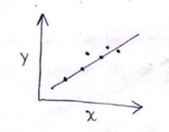8). Linear Regression is supervised algorithm where output a dependent variable is found from one or more independent variable

$$y=a+bx+4$$

a → intercept, b → slope  
 y → dependent variable  
 x → independent variable

The cost function / Loss function for linear regression is :

$$L=\sum_{i=1}^{n}{}(y_{i}-Ŷ_{i}) \\ y_{i}→Actualoutput \\ Ŷ_{i}→Predictedoutput$$

Logistic regression is a supervised algorithm where it is mainly used for the classification, i.e. classifying the data into their respective classes.

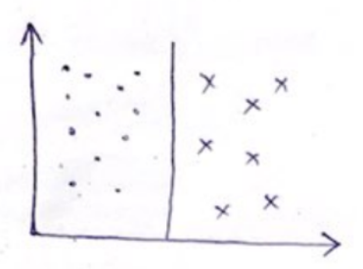

The cost function / loss function of Logistic regression is:

$$L=y_{i}log⁡(Ŷ_{i})+(1-y_{i})log⁡(Ŷ_{i}) \\ y_{i}→Actual output \\ Ŷ_{i}→P\text{redicted output}$$

The General Algorithm by which lort function are minimized are Lasss Regression & Ridge regression

$$\text{Fo}\text{r}\text{ L}\text{asso}: L(Lasso)=\sum_{i=1}^{m}{}(y_{i}-Ŷ_{i})^{2}+λ(m)$$

Here is absolute value of $m$ .

$$\text{Fox Ridge}: L(\text{Ridge})=\sum_{i=1}^{m}{}(y_{i}-y_{i-1})^{2}+λ(m^{2}) \\ ⇒λ(sin⁡x)\text{is a hyperparameter}$$

Here is a squared value of $m$ .